**OCTOCLEANER**

**Problem statement:**

Rainfall and agricultural runoff contain not only water, but also trash such as plastic, leaves, and muck. Rainfall and agricultural runoff pollute rivers and lakes, causing sedimentation and pollution. Sedimentation occurs when garbage and muck collect at the bottom of rivers, reducing the water capacity of rivers and lakes over time. It can't hold a lot of water. As a result, floods occur. (Floods can occur even if there is less rain.) It's one of the factors that contribute to flooding. The waste also pollutes the water supply.

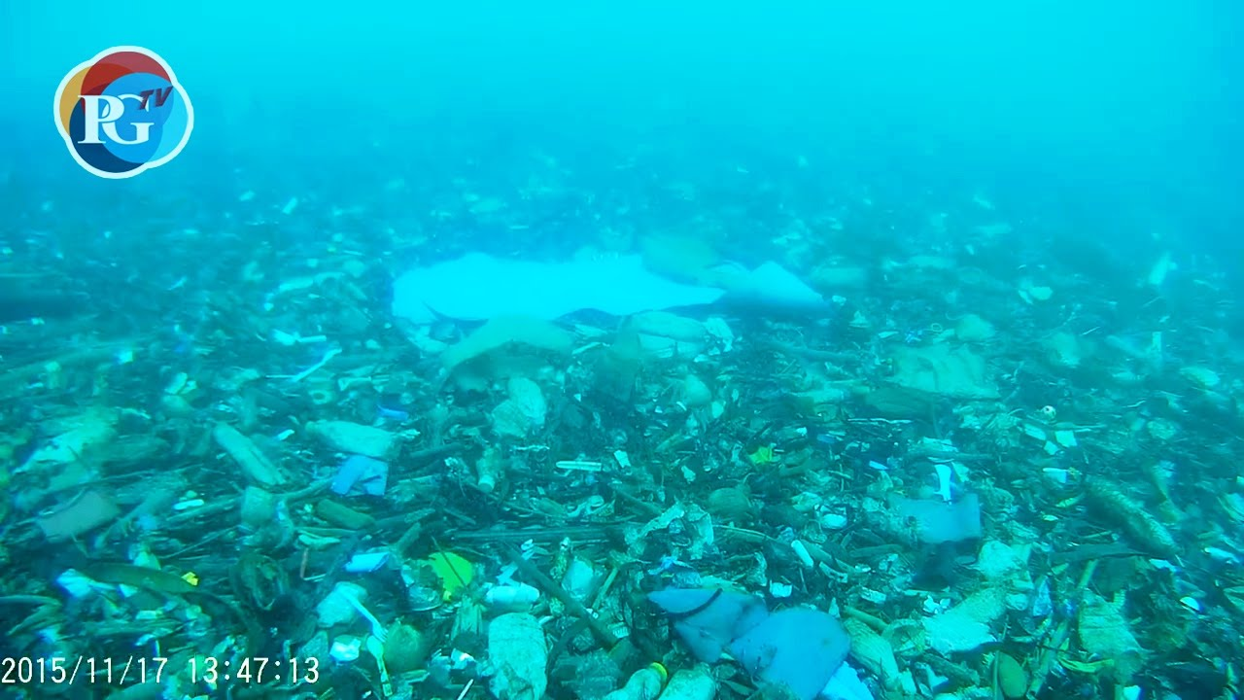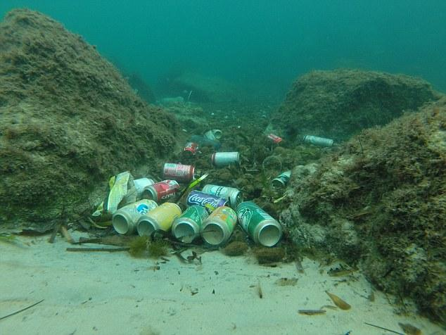

**Existing solutions:**

We didn't come across any type of device which can solve this problem.

There are a few machines that can clear trash up to a certain depth, but they can't clean waste deep within water bodies.

| **Name of the product** | **Jenny** | **Eco Six Packs Ring** | **The Toothpaste Pill** | **Ocean Clean up system** |
| --- | --- | --- | --- | --- |
| **Image** |  |  |  |  |
| **Price** | **Costs nearly 6 to 7 US cents per unit screen.** | **Costs nearly 10 and 15 US cents per 2 screens.** | **Costs nearly 7 US cents per unit.** | **Costs nearly 12 to 15 US cents per 3 screens.** |
| **Maximum Depth it can clean** | **Cleans upto 1.8meters from the starting point of waste.** | **Cleans upto 2.2 metres from the starting point of the waste.** | **Cleans upto 3.6 metres from the starting point of the waste.** | **Cleans up to 5.8 metres from the starting point of the waste.** |
| **Advantages** | **Cost is low compared to others.** | **It can clean 2 to 2.5 unit screens at a time.** | **Short device which is easily accessible.** | **It is accessible to clean 3 to 4 screens at a time.** |
| **Disadvantages** | **For one time it cleans only 1 unit screen.** | **Cost is high and sometimes the ring may get damaged.** | **Cost is comparatively high and it is not accessible to clean more than 1 unit screen.** | **Cost is too high which is non affordable.** |

**Proposed solution:**

OCTOCLEANER is an underwater robot that can go deep into the water and collect trash from within.

**Working**: The robot uses fins like structures for the motion. The streamlined shape of the robot reduces the friction with water and allows a smooth and fast motion.

The front and back part of the robot moves in opposite directions for forward motion. Camera attached to it can give a live feed to the user. The robot detects the depth of the water body and then it goes near to the bed. The camera attached to it sends the pictures to a machine learning model, then it detects the trash and gives commands to collect it. (octopus hands like structure) collects the trash and stores it in the tank. Ultrasonic sensors detect the height of trash in the tank, if it reaches to the limit then it comes up. After reaching to the surface the user can discharge the tank.

**Application:** Except for water bodies with excessive depth, our solution is applicable to rivers, lakes, ponds, and other water bodies.

**Inspiration:** we are inspired by biomimicry in engineering. We took aquatic animals as inspiration. Aquatic animals have streamlined shapes. It reduces the friction with water. Fishes are known for their flexibility and octopuses for their grip. We use fish mechanisms for motion and octopus mechanisms for collecting trash.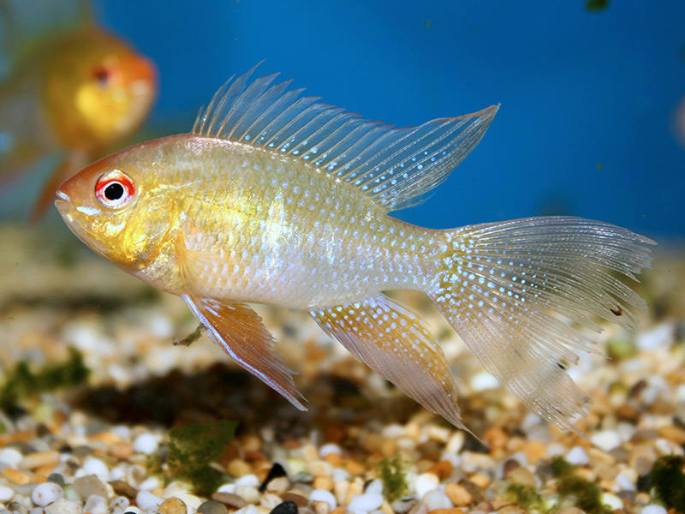

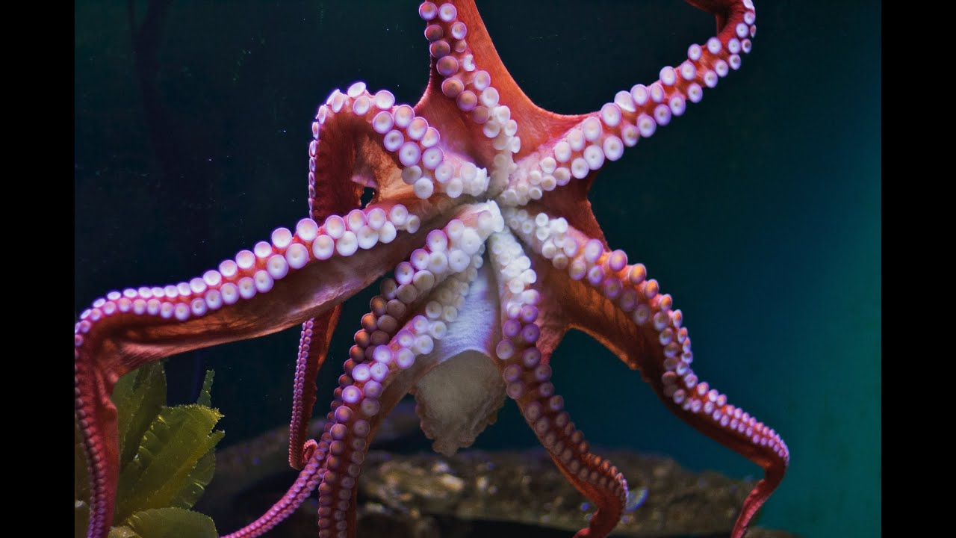

**Area of technology:**Machine learning, Internet Of Things, Mechanical core technology

**Progress:** research work is completed. Now working on prototype development.

**Future steps:** We intend to use this robot in the oceans as well, once we have the necessary resources and funding and we will periodically update it with the most recent technology. We also try to include a mechanism to collect the muck.